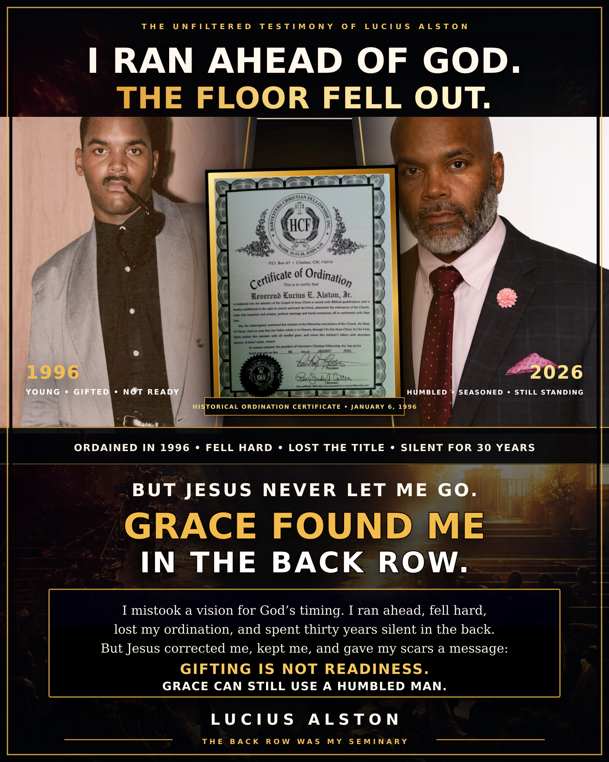

A TESTIMONY OF CALLING, COLLAPSE, CONSEQUENCE & GRACE

Before I Say Anything Else
  - The truth behind the certificate, the fall, the silence and the awakening
“I am not returning to demand a title. I am returning as a humbled man who wants his scars to warn the gifted, strengthen the fallen and point everybody to Jesus.”
— Lucius Alston
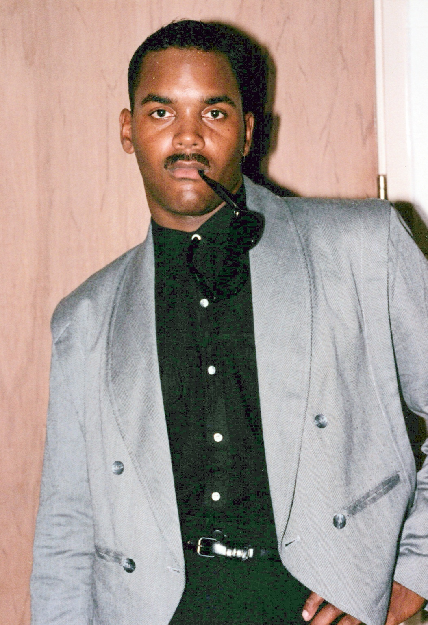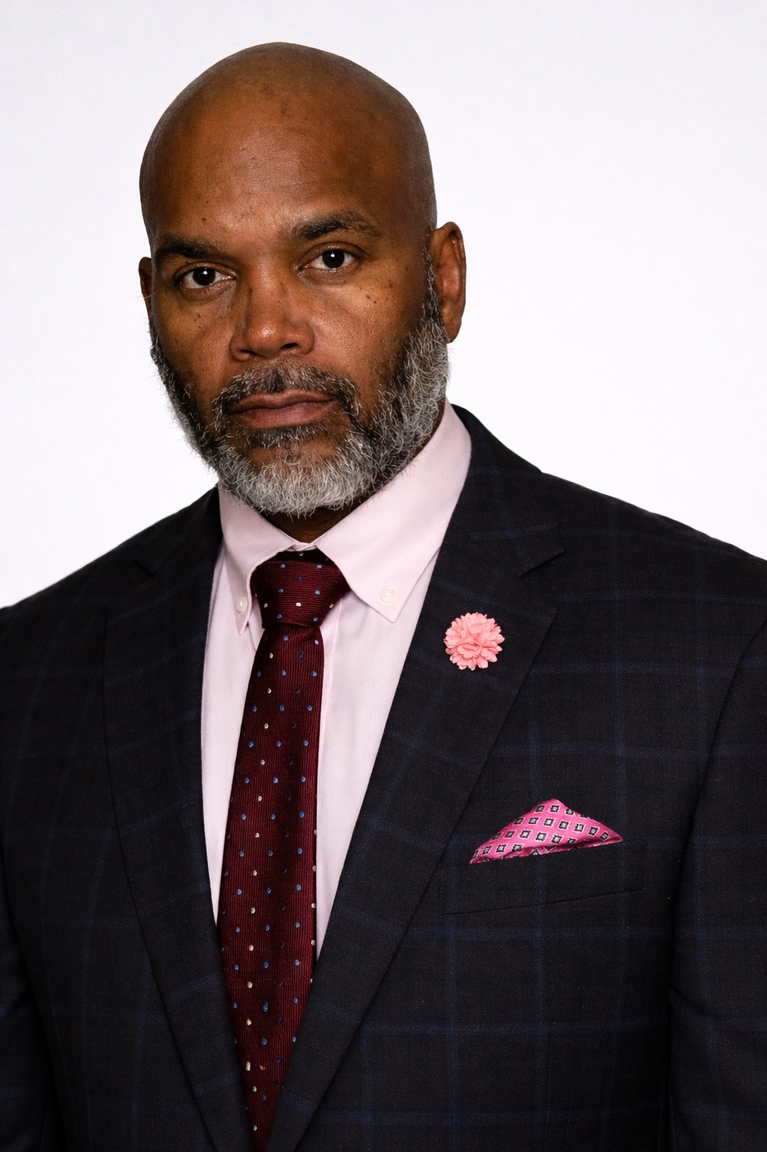
1996: young, gifted and running ahead • 2026: humbled, seasoned and still standing
On January 6, 1996, I held an ordination certificate in my hand and a vision of preaching before thousands in my mind. I was active in ministry. I was young, high-strung and ready to go. I believed there was a message in me, but I did not yet understand that receiving a vision and being ready to carry its weight are not the same thing.
I did not want to wait on God. I ran ahead of Him and was ordained in my time, not His. What followed was not the triumphant beginning I imagined. It felt as though the floor had been snatched from beneath me. Everything I loved in the world, every temptation connected to my weaknesses, seemed to arrive dressed beautifully and placed before me on a platter of gold. I did not have the strength, discipline or rooted character to say no. I fell, and I fell hard.
This testimony does not make the fall the hero. Jesus is the hero. I own what I chose, I accept what it cost, and I refuse to use grace as an excuse. Grace did not pretend that I had not fallen. Grace met me in the truth, stayed near through the consequence and refused to let shame have the final word.
PART ONE • THE FIRE

The Vision and the Young Buck
A genuine glimpse can still be mishandled by an unprepared messenger.
I had seen myself preaching in front of thousands. That vision put fire in me. It gave me a sense that my life could carry something larger than the room I was standing in. I did not understand then that God can show a destination without giving immediate permission to depart. A vision can be true while my interpretation of its timing is wrong.
I was a young buck—energetic, intense and eager to move. I wanted the pulpit, the responsibility and the confirmation. I mistook urgency for maturity. I thought being ready to speak meant being ready to stand. I understood gifting better than formation, opportunity better than accountability, and movement better than waiting.
“I mistook a vision for a schedule and a calling for permission to run.”

What I Could Not Yet See
Public ministry does not merely expose a gift; it exposes the whole person carrying the gift. The platform introduces pressure. Attention magnifies appetite. Access brings choices. Praise can feed pride, and opposition can reveal insecurities that were invisible in private. I wanted to carry the Word, but I had not yet learned how much of myself would have to be surrendered in order to carry it safely.
I now understand why Scripture warns against placing a novice into spiritual leadership. A novice may be sincere. A novice may be gifted. A novice may even be right about what he sees. But sincerity and gifting cannot substitute for tested character. The issue is not whether the fire is real. The issue is whether the vessel has been strengthened to hold it without breaking.
1 TIMOTHY 3:6 (KJV) “Not a novice, lest being lifted up with pride he fall into the condemnation of the devil.”
APRIL 7, 1995 • THE WARNING BEFORE THE FALL

When Knowledge Made Me Unreachable
Before the ordination came recognition—and I allowed recognition to tell me I had arrived.
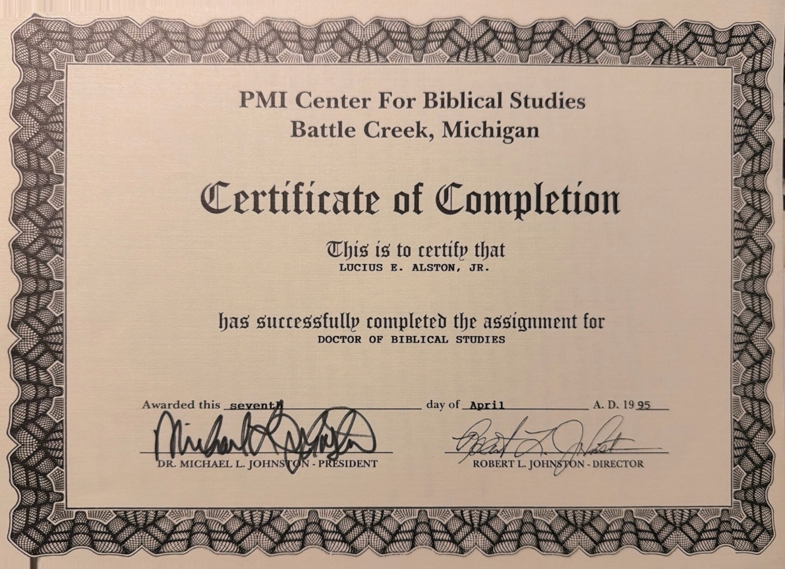
Historical certificate of completion dated April 7, 1995. Included as part of this testimony—not presented as proof of current ministry office or independently verified academic standing.
Before the ordination certificate came another document. On April 7, 1995, I received a certificate of completion connected to Doctor of Biblical Studies work. Instead of allowing that achievement to make me more humble and teachable, I allowed it to make me proud.
I got the big head. I became a know-it-all. I became difficult to reach and hard to correct. I always needed to be the teacher, but I had stopped being a student. I knew how to explain Scripture, but I had not yet allowed Scripture to examine me.
The certificate did not create the pride; it exposed and fed what was already growing inside me. My knowledge increased faster than my humility. I mistook information for formation and recognition for readiness.
Looking back, the warning signs were present before I was ordained. The fall did not begin when temptation appeared after ordination. It had already begun quietly—when pride convinced me that I knew enough, had arrived, and no longer needed anyone to correct me.
“I had learned enough Bible to impress people, but not enough humility to remain teachable.”

I Ran Ahead
Waiting felt like delay to me. Preparation felt slower than the vision. I wanted outward confirmation of what I believed inwardly, so I moved ahead. I received the certificate, the title and the authorization before the hidden parts of my life had been sufficiently disciplined for what could follow. The paper was real, but paper could not create the maturity I had skipped.
WHAT I KNOW NOW
God's timing is not an obstacle to calling. His timing is part of the calling.
PART TWO • THE ARTIFACT

A Certificate Before the Season
The document records January 6, 1996. It also marks the beginning of a lesson I would spend thirty years learning.
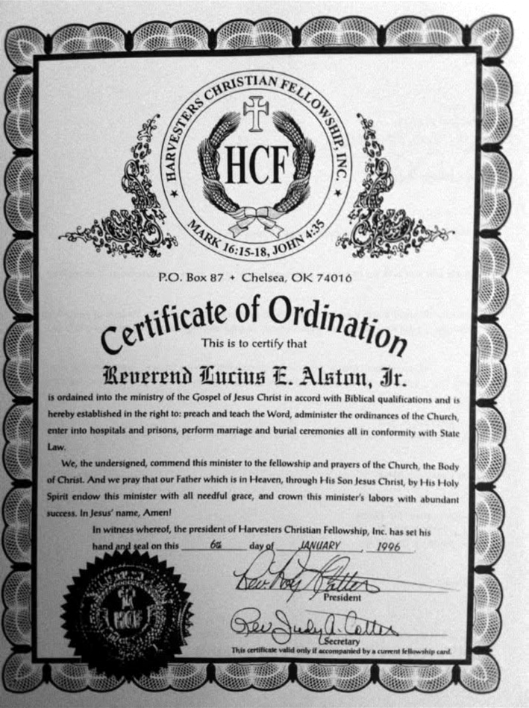
Historical ordination certificate issued January 6, 1996. Included as part of this testimony and not represented as a current ministerial credential.
For years, this certificate could have been treated as either a trophy or a wound. It is neither. It is evidence. It proves that the moment happened, but it cannot tell the whole truth about the man who stood behind it. It shows the day I was ordained; it does not show the character I had not yet developed, the temptations that were coming, the choices I would make or the consequences I would carry.
The certificate records what happened in 1996. It does not authorize what happens next. I will not use an old document to appoint myself to a present office. Grace may restore a man to fellowship and usefulness, but a church must discern an office. If God chooses to open another door, I want it opened through truth, present fruit, accountability and spiritual covering—not through the impatience that harmed me the first time.
INTEGRITY GUARDRAIL
The old certificate is part of the testimony, not proof of current credentials. The story becomes stronger when that distinction is made plainly.
PART THREE • THE COLLAPSE

When the Floor Fell Out
Elevation revealed weaknesses that excitement had allowed me to ignore.
As soon as I was ordained, it was as though the floor was snatched away. The world did not approach me looking ugly. Temptation did not introduce itself as destruction. It came attractively. It touched the things I already loved and the weaknesses I had not conquered. It was presented like something valuable—like a platter of gold.
I did not have the strength to say no. That sentence is not an excuse. It is a confession. I made choices. I crossed lines. I failed to guard the witness I had publicly claimed. The problem was not merely that temptation existed; temptation will always exist. The problem was that I had reached for public responsibility without submitting every private appetite to the kind of discipline that responsibility required.
“A gift can fill a room, but it cannot mature the man carrying it.”

I Fell Hard
My fall brought shame to my witness and dishonor to the Christ I claimed to represent. My ordination was stripped from me. There were consequences that prayer did not erase and a reputation that good intentions could not immediately repair. I learned that forgiveness does not always remove earthly results. Mercy and consequence can sit in the same pew.
The details do not need to be made sensational for the repentance to be real. I do not need to make sin entertaining in order to make grace impressive. The important truth is that I chose wrongly, I fell publicly, I lost what I had rushed to obtain, and I could no longer pretend that gifting had made me ready.

What Shame Told Me
Shame told me that silence was the only place left for me. It told me that my voice had become dangerous, that my history had disqualified every future act of service, and that the safest thing I could do was stand in the back, keep my mouth closed and never let anyone see the certificate or hear the story. So that is largely what I did.
THE DIFFERENCE
Conviction says, 'Tell the truth and turn.' Shame says, 'Hide forever and become the worst thing you ever did.'
PART FOUR • THE SILENCE

Thirty Years in the Back Row
What felt like the end slowly became a classroom in humility, consequence and grace.
After 1996, I stood in the back and kept my mouth closed. I watched other people preach. I heard invitations, sermons, prayers and songs while carrying a private history that few people could see. The sanctuary could be full, yet shame could make me feel alone. I knew what it was to have once reached for the front and then decide that the back was the only honest place left for me.
Those years were not simple. Silence can be humility, but it can also become hiding. Staying out of the way may protect others for a season, but permanent disappearance is not always the same as repentance. Repentance is willing to walk in the light, accept boundaries, make appropriate amends and serve without entitlement. Shame wants no process at all because shame believes the sentence has already been made final.
“The back row became my seminary—not because failure was good, but because Jesus refused to waste the truth it taught me.”

What Time Did to the Message
Time put weight into words I once used too quickly. Grace stopped being a slogan and became the reason I was still standing. Accountability stopped feeling like interference and became protection. Waiting stopped looking like God withholding something from me and began to look like God refusing to let the gift outrun the man again.
The young man wanted to preach because he had seen a crowd. The seasoned man wants to speak because he has seen what pride, weakness, consequence and mercy can do to a life. The young man wanted to prove that he had been called. The older man has nothing left to prove. If the message helps one young minister wait, one fallen man repent, or one ashamed soul return to Jesus, then the scar has become useful.
I cannot call those thirty years wasted simply because they were painful. I also will not romanticize them. Some pain came from choices that never should have been made. Yet Christ met me in what remained. The back row did not become a shortcut around consequence; it became the place where I finally began to understand why character must be built before visibility increases.
PSALM 51:12–13 (KJV) “Restore unto me the joy of thy salvation; and uphold me with thy free spirit. Then will I teach transgressors thy ways; and sinners shall be converted unto thee.”
PART FIVE • THE AWAKENING

The Seasoned Man Wakes Up
I no longer want to run ahead. I want to walk behind Jesus and serve wherever He leads.
Now, in 2026—thirty years after the date on that certificate—I sense that something in me has awakened. This does not feel like the young man's hunger for a title. It feels like a worn man's burden to tell the truth. I am not polished by perfection. I am marked by consequence, kept by mercy and sobered by what I know can happen when gift moves faster than character.
I understand now why a spiritual leader must not be a novice. You cannot handle what is coming merely because you can preach. The enemy studies appetite. Visibility increases access. People may applaud the gift while never seeing the fractures beneath it. If a man has not learned to be corrected, to wait, to confess, to submit and to say no in private, the public place he desires may become the place that exposes him.
“I am not returning as the young man who wanted thousands. I am returning as the seasoned man willing to help one soul at a time.”

The Vision May Look Different
The thousands I saw may never gather in one building. They may be readers opening a book, listeners pressing play on a song, viewers watching a testimony, men sitting in a small group, prisoners receiving hope, or young ministers hearing a warning before they make my mistake. I do not have to force the vision into a particular architecture. My responsibility is faithfulness. God can decide the room, the method and the reach.
Today I already have avenues the young man in 1996 could not have imagined: books, Kingdom Sound music, video, a website, ministry resources and the ability to speak across distance. These platforms must never become replacements for character or spiritual covering. They are simply tools. The message is Jesus. The scar opens the door, but Christ must remain the destination.
LUKE 22:32 (KJV) “But I have prayed for thee, that thy faith fail not: and when thou art converted, strengthen thy brethren.”
THE JOURNEY AT A GLANCE

A Thirty-Year Timeline
The same facts look different when viewed through the lessons they produced.
Season | What happened | What it taught me
April 7, 1995 | Recognition and pride | I received a certificate of completion in biblical studies. Instead of letting recognition deepen humility, I allowed it to feed pride, make me unteachable, and convince me I was ready.
1996 | Vision and youthful zeal | I saw myself preaching before thousands, but I treated the vision as permission to move immediately.
Jan. 6, 1996 | Ordination | I received a certificate before I had been sufficiently seasoned to carry what came with public ministry.
After ordination | Collapse and consequence | Temptation exposed what gifting had hidden. I fell hard, dishonored my witness, and lost the ordination.
1996–2026 | The back row | I remained quiet and out of the way. Shame kept me hidden, while time, truth and consequence taught me what ambition could not.
2026 | Awakening | I do not return to demand a title. I return as a worn, humbled man who wants his scars to warn the gifted and strengthen the fallen.
The timeline records a journey; it does not turn the former certificate into a present credential. Any future office belongs under current spiritual accountability and church discernment.
“The certificate marked a date. The back row shaped a witness. Grace is writing what comes next.”
PART SIX • THE LESSONS

What the Back Row Taught Me
Seven truths I wish the young man in 1996 had understood.

Lesson 1 — A Vision Is Not a Schedule
God may show a destination long before He authorizes movement. Seeing something does not mean I am ready to carry it, and delay does not mean denial. Sometimes the wait is where God builds the man who can survive the answer.

Lesson 2 — Gifting Is Not Readiness
A person can communicate powerfully and still be weak in unexamined places. Gift may open a door, but character determines what happens after the door opens. The gift is not proof that every part of the carrier has matured.

Lesson 3 — Character Must Carry the Call
Private disciplines are not minor details. Truthfulness, sexual integrity, financial integrity, humility, submission, prayer, patience and the ability to receive correction are load-bearing beams. The platform eventually leans its entire weight on them.

Lesson 4 — Elevation Introduces New Warfare
What is manageable in obscurity can become dangerous under attention. Access changes. Praise changes. Expectations change. Temptation may arrive looking like reward. A leader must prepare for what visibility attracts, not only for what the assignment requires.

Lesson 5 — Consequences Do Not Cancel Grace
Grace does not always return everything I lost, and it does not call every boundary unfair. Grace gives me the courage to face the truth, receive correction and become useful without demanding that usefulness take the form I once imagined.

Lesson 6 — Restoration Begins Before a Title
A man can be restored to honest fellowship, prayer, service and witness without appointing himself to office. The first evidence of restoration is not a new title. It is sustained repentance, observable fruit, accountability and a willingness to serve where no applause is promised.

Lesson 7 — The Scar Must Point Beyond Me
If the testimony only makes people admire my survival, it has stopped too soon. The testimony must point to Jesus—the One who confronted me, disciplined me, stayed near, gave me time to mature and can use surrendered lives without pretending the past never happened.
THE SENTENCE I CARRY
I would rather walk behind Jesus into a small assignment than run ahead of Him toward a crowd.
PART SEVEN • THE MESSAGE

To the Gifted and to the Fallen
The same testimony carries a warning in one direction and an invitation in the other.

A Word to the Gifted
Do not confuse applause with confirmation. Do not let a powerful moment convince you that formation is optional. Do not despise the pastor, mentor, spouse, elder or friend who asks hard questions about your private life. Correction may feel like someone slowing you down, but the right correction may be God keeping the floor beneath you.
Let God develop the part of you that nobody can celebrate yet. Learn to say no before the offer comes. Learn to tell the truth before exposure forces it. Learn to serve when no title is attached. Learn to wait without becoming bitter. Your gift may be real, but the warfare around the gift is real too. You cannot rebuke every consequence of being unprepared.
“Better hidden and ready than visible and unguarded.”

A Word to the Fallen
Your failure may have changed what you can responsibly do, but failure does not make repentance meaningless. Do not use grace to bypass accountability, and do not use shame to avoid it. Come into the light. Tell the truth. Respect boundaries. Make appropriate amends where possible. Accept that some trust must be rebuilt slowly and that some roles may never return.
But do not assume that the only faithful future is permanent hiding. You can pray. You can serve. You can encourage. You can warn someone away from the road that broke you. You can become dependable in small things. You can let Christ produce fruit where pride once demanded a platform. The question is no longer, 'How do I get my old place back?' The question is, 'Jesus, how can this surrendered life serve You now?'
JOHN 21:17 (KJV) “Jesus saith unto him, Feed my sheep.”
PART EIGHT • THE POSTURE

Restoration Without Entitlement
I seek usefulness under authority—not a shortcut back to recognition.
My testimony cannot ordain me. A book cannot ordain me. A song, a website, a vision or an old certificate cannot ordain me for the present. If formal ministry office is ever considered again, that decision belongs in the hands of current spiritual leadership examining doctrine, character, accountability, relationships, fruit and the full truth of my history.
My posture is not, 'Give me back what I lost.' My posture is, 'Help me discern how to serve faithfully.' I want to submit this testimony to pastoral review, protect the people and institutions around me, avoid presenting an invalid credential as current, and accept whatever boundaries responsible leaders believe are necessary.
Where anyone was harmed by my choices, public testimony does not replace personal responsibility. Telling a powerful story cannot become a substitute for making appropriate amends, honoring privacy, respecting safeguards or accepting consequences. The credibility of the message depends on the continuing integrity of the messenger.
“Grace restores the man. The church discerns the office.”

My Posture Now
I do not need the front row in order to obey Jesus. I do not need thousands in order for one soul to matter. I do not need to pretend that 1996 did not happen. I can carry the truth of it without letting it become my identity. I am a man who fell, but I am not only the fall. I am a man who was corrected, kept and given time to become honest about what the gift could not do for me.
If God gives me a pulpit, I will preach Jesus. If He gives me a song, I will sing Jesus. If He gives me a book, I will write Jesus. If He gives me one wounded man in a back pew, I will sit beside him and tell him the truth. This time, I do not want to run. This time, I want to wait.
THE SCRIPTURE SPINE

The Word Beneath the Testimony
These passages do not erase the past. They give the testimony its direction.
1 TIMOTHY 3:6 (KJV) “Not a novice, lest being lifted up with pride he fall into the condemnation of the devil.”
This is the warning I understand now: spiritual visibility without tested maturity can become dangerous to both the messenger and the people watching him.
PSALM 51:12–13 (KJV) “Restore unto me the joy of thy salvation; and uphold me with thy free spirit. Then will I teach transgressors thy ways; and sinners shall be converted unto thee.”
David's prayer connects restoration with responsibility. The restored person does not merely feel better; he uses truth to help others turn.
LUKE 22:32 (KJV) “But I have prayed for thee, that thy faith fail not: and when thou art converted, strengthen thy brethren.”
Peter's failure did not become the center of his message. Christ's intercession and Peter's conversion prepared him to strengthen others.
2 CORINTHIANS 4:7 (KJV) “But we have this treasure in earthen vessels, that the excellency of the power may be of God, and not of us.”
The vessel is not the treasure. My weakness should make Christ's power more visible, not make my story more important than His gospel.
JOHN 21:17 (KJV) “Jesus saith unto him, Feed my sheep.”
Restored love becomes service. The assignment is never to worship the platform; it is to care for the people who belong to Jesus.
CLOSING

A Prayer of Surrender
Not my timing. Not my title. Not my crowd. Jesus, have Your way.
Lord Jesus, I thank You for telling me the truth about myself and refusing to leave me inside the lie that my gift was enough. I confess the pride, impatience, appetite and disobedience that helped carry me ahead of Your timing. I do not blame the platform, the temptation, the people around me or the enemy for choices that were mine. I ask for mercy, wisdom and the courage to keep walking in the light.
Thank You for keeping me when I could not keep myself. Thank You for correction that did not feel comfortable and consequences that taught me what excitement could not. Heal what can be healed. Help me honor every boundary that should remain. Where amends are possible and appropriate, give me humility to make them without demanding a particular response.
Season my words before I speak them. Guard my private life more fiercely than any public image. Place me under wise spiritual covering. Make me content to serve without recognition. If You send thousands, keep me humble. If You send one, help me be faithful. Let every book, every song, every testimony and every opportunity carry people past my story to Your cross, Your grace and Your lordship.
I do not ask You to restore an image. Restore integrity. I do not ask You to make people forget. Help them see honest fruit. I do not ask for the front row. Teach me to follow wherever You lead. This time, Lord, I will wait. Amen.
“If my scar can keep one gifted young minister from running ahead—or help one fallen soul come out of hiding—then even the wreckage of my past can point to Christ.”

My Closing Declaration
I was ordained in 1996. I ran ahead of God. I fell hard. I lost the title I had rushed to obtain, and for thirty years I stood in the back with my mouth closed. But Jesus did not abandon me. He corrected me, humbled me, seasoned me and gave my scars a message.
I am not returning to make Lucius Alston the center. I am returning to say that gifting is not readiness, waiting is part of obedience, consequence does not cancel grace, and Jesus can still use a surrendered, humbled man.
THE TESTIMONY IN ONE LINE
I ran ahead of God, the floor fell out, and grace found me in the back row.
Lucius Alston
Thirty years after January 6, 1996
© 2026 Lucius Alston. All rights reserved.

